Welcome to my 256th blog posting. If you are one of my loyal readers, you probably already know why that is significant. Regardless, I’ll be “celebrating” by going over the filestore server...
One of the major architecture changes in Vault 2014 is the filestore server. In order to explain this architecture, I need to first explain how things worked in 2013.
If you had a multi-site environment in Vault 2013, it looked like this.
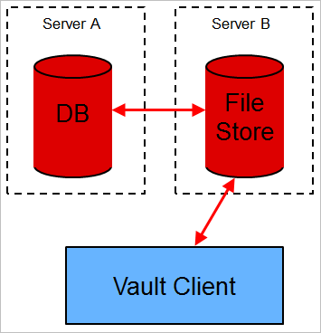
There is a problem with this architecture, every time you need data from the database, you need to go through two hops. Just about everything you do in Vault requires the database, so going through 2 hops is inefficient.

For Vault 2014 the architecture, was updated to look like this.
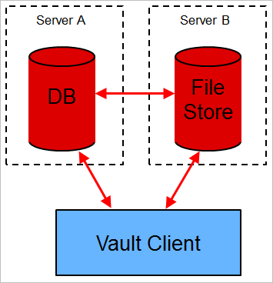
DB calls go directly to the database, so it’s only one hop. That efficiency comes at a cost however. The new architecture is more complex.

Things that may be confusing:
- This architecture is always in place, even for Vault Basic and single-site installs. It’s just easier to have 1 architecture.
- For multi-site, a client will actually be talking to two different servers.
- You log in to the filestore server.
- Internally the WebServiceManager or Connection object asks the filestore server where the database server is located.
- File upload/download operations require communicating with both servers. Again, the Connection object handles the details internally.
- For backward compatibility purposes, the filestore server handles all 2012 and 2013 web service calls.
- There are now two sets of server log files.

The functionality is broken down by web service. So some services are on the database server and some are on the filestore server. There are no services that show up on both, with the exception of the Information Service.
Filestore services:
- AuthService
- FilestoreService
- FilestoreVaultService
- IdentificationService
- InformationService
Database services:
- AdminService
- BehaviorService
- CategoryService
- ChangeOrderService
- ContentService
- CustomEntityService
- DocumentService
- DocumentServiceExtensions
- ForumService
- InformationService
- ItemService
- JobService
- KnowledgeVaultService
- LifeCycleService
- PackageService
- PropertyService
- ReplicationService
- RevisionService
- SecurityService
The URLs are different too depending on which server you are talking too. Database services are http://[server]/autodeskDM/services/v18/[service].svc while filestore services are http://[server]/autodeskDM/services/filestore/v18/[service].svc. But you shouldn’t have to care about that if you are using WebServiceManager or Connection.

